What is a Mouse?

The generation of students entering elementary school today doesn’t remember a day without iPhones, iPads, tablets, and touch screen computers. It is easy for children to just touch or drag their finger across a screen to play a game, open an app, type, or select an answer—and they are very good at it! Unfortunately, many of the online assessments used in school today require students to use an old-fashioned computer mouse to select answers—a skill that is quickly becoming a lost art in today’s world.
During our specials rotation, all students at Mountain View attend Computer class once a week. Mrs. Taylor teaches the technology skills they will need to be successful in school, including how to use the mouse because strong mouse skills are essential for your child’s success at school, especially for online testing.
Kindergarteners begin the year learning how to “click”, “double click” and “click & drag”. For many of them, just handling the mouse and learning how to control it can be very difficult. Many struggle with clicking on the correct side of the mouse. Parents are strongly encouraged to help their child work on mouse skills to reinforce what they are learning in computer lab. Please practice and model these skills with your child at home. If you don’t have a traditional mouse on your home computer, you might want to consider adding one for your child to use. Always have them use their pointer finger to click the left side of the mouse and remind them to click near top of the mouse—Mrs. Taylor teaches them to “click the end by the mouse’s tail” because our devices are not wireless.
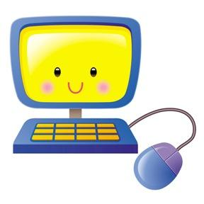
Using a mouse is a great exercise to help develop your young child’s hand-eye coordination and fine motor skills. You can easily search for games on the internet that school age children can use to practice mouse skills, or you can use the games on the Kindergarten page of the Computer Lab blog on the Mountain View website for practice.
Thanks so much for your help and happy clicking!

