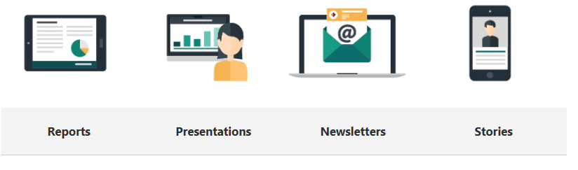
How to Sway

Logging into Sway | In your Office 365 account, click on the Sway tile. (You can also access Sway from the app launcher located in the upper left corner of Office 365.) | 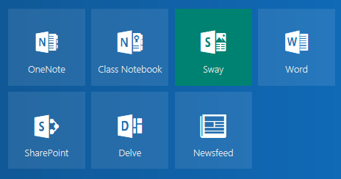
Create a new Sway | 2. On the My Sways page that opens after you’ve signed in, click or tap Create New to start creating your first Sway. | 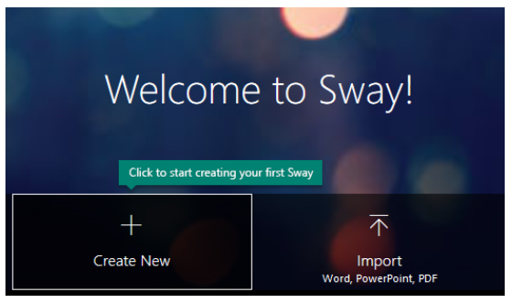
The Sway Storyline | The Storyline is where you type, insert, edit, and format the content that tells your story. Content is arranged in sequential order by adding “Cards.” Each card holds the type of content you want — such as text, images, videos, and even Office documents. The order of cards can be rearranged at any time. | 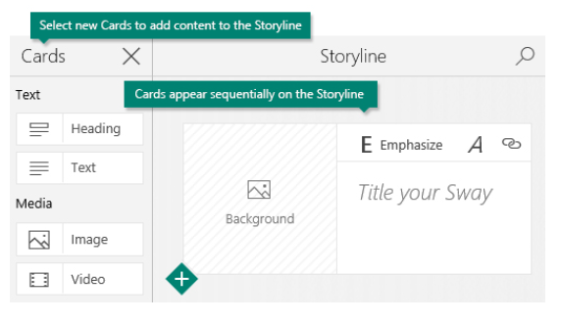
Give your Sway a Title | Click the Title your Sway placeholder text shown in the first card on the Storyline, and then type a short but meaningful description of what your Sway is all about. When you share your finished Sway later, this title will be the first thing that others will see. | 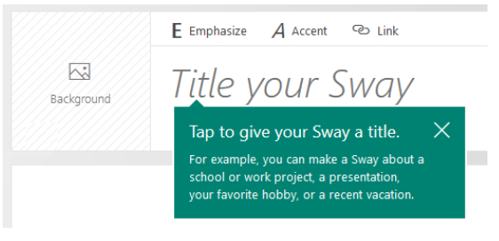
Add Images and Text to your Sway | To add basic content to your Sway, such as text and images, click or tap the <+> icon in the bottom left corner of any card, and then choose the type of content you want to add. To see all available options, click Cards on the top menu bar. If you prefer, you can also drag and drop text and images right onto your Storyline. | 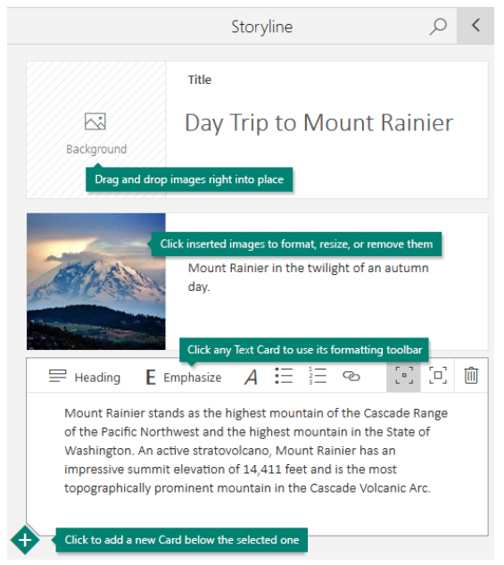
Add Content to your Sway | On the top menu bar, click Insert, select your content source from the menu, and then enter any search keyword or phrase into the Search sources box. | 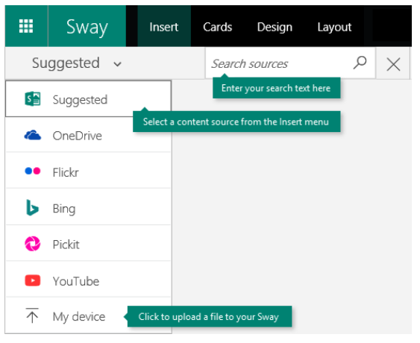
Preview your Sway | You can preview your work in progress at any time by clicking the left-facing arrow next to the Preview pane near the upper right. When you preview your Sway, you can see how it will appear to others when you later decide to share it. To fully experience your Sway (including any interactivity options that you’ve added on the Layout menu), click the Play button on the top menu bar. | 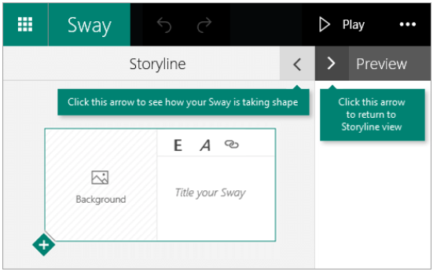
Change the Design and Layout of your Sway | To choose a design for your Sway, click Design on the top menu bar, and then select the theme you want. To choose a random look for your Sway at any time, click the Remix! button on the top menu bar until you find a design that suits your taste. You can also adjust a specific part of the currently applied theme, such as color, font choices, and the emphasis of animation by clicking the Customize button in the Design pane. | 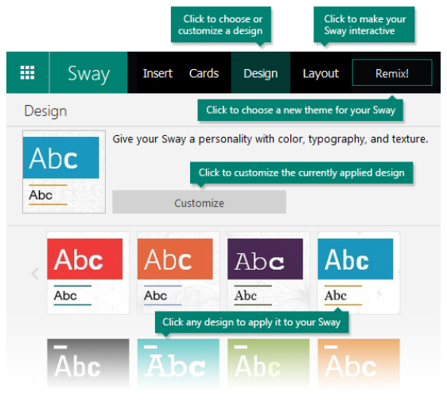
Share your Sway | Click the Share button on the top menu bar and then select how you want to share your Sway. Your choices on this menu depend on the type of account that you used to sign in to Sway. | 